Greek Modernism
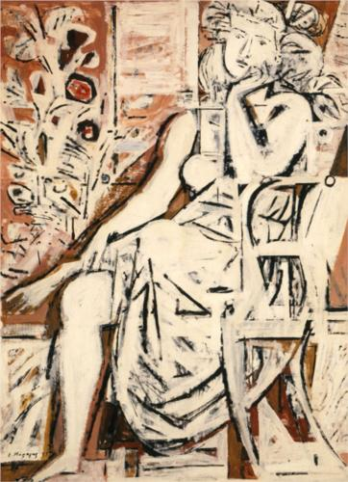
With a call for ‘bold conceptions’ and ‘broad syntheses’, novelist George Theotokas presented in his 1929 essay ‘Free Spirit’ the manifesto of Greek modernity: ‘What position does Greece hold,’ he asked, ‘within the creative ferment of modern Europe?’ George SEFERIS, one of the main figures of the Generation of the Thirties that forms the core of Modernism in Greece, and later a Nobel laureate, translated T.S. ELIOT’s The Waste Land (Έρημη Χώρα, 1936) as he was writing his influential poetic sequence in free verse Mythistorema, published in 1935. This annus mirabilis of Greek poetry also saw the publication of surrealist Andreas Embeirikos’s Blast Furnace/Υψικάμινος and the first volume of C.P. CAVAFY’s Collected Poems, as well as the establishment of the literary journal New Letters/Τα Νέα Γράμματα. That year also saw the publication of The Nights of Phemius/Οι Νύχτες του Φήμιου, the last collection by poet Kostes Palamas, the nation’s bard and a champion of demoticism in the Greek language question, but also a proto-modernist who experimented with verse structure and temporal mosaics as early as 1907 in his long poem The Twelve Lays of the Gypsy/ Ο Δωδεκάλογος του Γύφτου. As Seferis noted in his 1963 Nobel Lecture, Palamas was a most important critic whose wide knowledge of foreign literatures proved that ‘Greece is a crossroads’. Explorations of the concept and meaning of myth and free verse, spatial time, orality and textuality, are all traits of Greek modernism created as a reaction to the self-reflexivity of what Seferis called ‘the generation of Karyotakis’, after the Greek poet Kostas Karyotakis and his poetry of disillusionment, and building upon the work of Palamas and the writers of the 1880s as well as poets and dramatists such as Angelos Sikelianos. Poet Nanos Valaoritis has written that Seferis’s lengthy introduction to The Waste Land, which spoke of a dialogue amongst poetic traditions, served as the ‘modernist manifesto for the Greek poetry of the Thirties’ (Valaoritis, ‘A Memoir’).
Yannis Moralis, ‘Daydreaming’ (1959)

In the 1930s, an abundance of new literary magazines published foreign writers and essays in translation; among them, a 1933 issue of The Circle/ Ο Κύκλος dedicated to ELIOT and translated passages from JOYCE’s ULYSSES in the avant-garde magazine The Third Eye/Το 3^{ο} Μάτι in 1936. Painter-poets Nikos Engonopoulos and Andreas Embeirikos, as well as the future Nobel laureate ODYSSEUS ELYTIS, presented their experimentations in the spirit of DADA and SURREALISM (in 1938 Engonopoulos translated poems by TRISTAN TZARA and published them in the volume Sur(r)ealism I and Engonopoulos published his first book of poetry, Do Not Speak to the Driver/Μην Ομιλείτε εις τον Οδηγό), and painters such as Nikos Hadjikyriakos-Ghika, Yannis Tsarouchis, Yannis Moralis and Spyros Vassiliou presented their work in Panhellenic Exhibitions. At the same time, a dialogue on poetry and the meaning of Hellenism between Seferis and Konstantinos Tsatsos, Professor of Philosophy at Athens University, became emblematic of the period’s focus on tradition and the clash between what came to be known as ‘European Hellenism’ and ‘Greek Hellenism’. A search for immediacy in art that western modernists saw in myths and folklore art in general, found an equivalent in Greek letters of the time in an interest in the memoirs of General Makriyannis (1797-1864), the paintings of Hadjimichail Theofilos (1874-1934) and the long poem Erotokritos/Ερωτόκριτος by Vitsentzos Kornaros (1553-1613/14). It was in the 1920s and 1930s that folklorist Angeliki Hatzimichali worked to further progress the preservation and propagation of Greek Folk Art. Poets, novelists, painters, essayists, architects, choreographers and dramatists, in both Athens and Thessaloniki, experimented with new forms and worked to find a modern analogy that could transpose their experiences into art and thus translate modern Greece to a contemporary audience. The long list of names includes, among many others, poets George Sarandaris, Theodoros Doros and Nikos Gatsos, novelists Elias Venezis and M. Karagatsis (Dimitris Rodopoulos), architects Dimitris Pikionis, Aris Konstantinidis and Takis Zenetis, painters Konstantinos Parthenis and Fotis Kontoglou, theatre director Karolos Koun, choreographers Rallou Manou and Zouzou Nikoloudi, photographers Nicholaos Tombazis and Voula Papaioannou.
In the meantime, the map of Greece was changing with the two Balkan Wars in 1912-13, the Greco-Turkish war of the years 1919-22, and the influx of refugees as a result of these, while the Metaxas dictatorship (1936-41), the country’s occupation by Nazi Forces until the end of the Second World War, the civil war that erupted afterwards and the 1950s period of reconstruction and Communist persecutions, left the country deeply scathed. SURREALIST poet and theorist NICOLAS CALAS wrote that the First World War lasted in Greece four years longer than it did anywhere else and came to an end ‘only with the disaster of Asia Minor in 1922’, and the compulsory exchange of populations signed at Lausanne in 1923, while the two generations of the interwar period, between 1922 and 1940, ‘finished their school days either on the battlefront or in Turkish prisons or they spent all their childhood under the nervous strain of both foreign and civil wars’ (CALAS, ‘The Greek Door to Europe’). Since some of the leading representatives of Greek MODERNISM moved from their lost homes in Anatolia to the urban capitals of Europe (SEFERIS, Theotokas, and the novelist Kosmas Politis) and others either spent years abroad (ELYTIS, Stelios Xefloudas, N.G. Pentzikis), moved to the Greek capital (Stratis Myrivilis, Angelos Terzakis) or lived as political exiles in the 1950s (Melpo Axioti, Yannis Ritsos), Greek MODERNISM is characterised by a mobility across frontiers (Tziovas, ‘Introduction’, in Greek Modernism and Beyond, 3-4). A special mention should be made to novelist, dramatist, translator and travel writer Nikos Kazantzakis, a self-proclaimed student of Homer, Dante, BERGSON, and NIETZSCHE, whose Zorba the Greek/Αλέξης Ζορμπάς, written during 1941-42, was the first in a series of novels presenting mythical versions of Greekness.
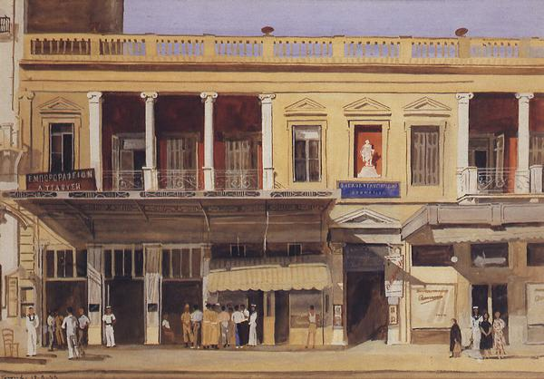
In 1936 photographs of the demonstrators killed at a strike by tobacco workers in Thessaloniki on May 8th prompted Yannis Ritsos to write his celebrated poem Epitaphios/Επιτάφιος (the first book of modern Greek poetry to be burnt together with five hundred others in 1938), which Mikis Theodorakis set to music in 1960 using folk instruments and untrained musicians and singers. In 1962, composer Manos Hadjidakis captured the tragic atmosphere of 1945, when the Civil War had already exploded in Greece, in his Lilacs out of the Dead Land/Πασχαλιές μέσα από τη Νεκρή Γη, a selection of rebetika songs brought over from Anatolia by the 1920s refugees. As the period of reconstruction in post-war Europe brought the growing financial, political and cultural influence from over the Atlantic, the overflow of imports also disseminated the voices of the Beats, WALT WHITMAN and Bob Dylan to the increasingly socially aware Greek youth of the 1960s at a period when Greek modernism was also popularized with a wealth of publications and poems set to music.
Yannis Tsarouchis, ‘Cafe Parthenon’ (1954)

From the late Forties onwards, a suggested orientation towards the legacy of Eastern Orthodoxy and Byzantium came to counteract the Thirties’ look to the West, and Zesimos Lorenzatos’s 1961 essay ‘The Lost Centre’, which called for a return to the metaphysics of Christian mysticism, is considered the antipode of Theotokas’s ‘Free Spirit’. After a seven-year military dictatorship (1967-74), the modernist tropes had already mutated, as the Metapolitefsi era [return to multi-party democracy from 1974 onwards] that was just beginning called for new narratives. Still, cultural products such as Theodoros Angelopoulos’s films, produced from the 1960s onwards and following the modernist aesthetics of Elytis and Seferis by offering a non-linear narrative of identity, myth and historical memory, Stratis Tsirkas’s trilogy Drifting Cities, novels set in Jerusalem, Cairo and Alexandria, or Stelios Xefloudas’s Odysseus, a novel by a pioneer of the introverted novel written in 1967 and published in 1974, show that Greek modernism forged a resonant and distinctive way of constructing the myths of a cosmopolitan modern Greece.

References and Further Reading

Primary Sources
Calas, Nicolas (1941) ‘The Greek Door to Europe’, Decision, I/2 (February), 45.
Theotokas, George (1986) ‘Free Spirit’ (1929), tr. Soterios G. Stavrou, Modern Greek Studies Yearbook 2, 159.

Secondary Sources
Beaton, Roderick (2011) ‘Greece’, The Cambridge Companion to European Modernism, ed. Pericles Lewis, Cambridge: Cambridge University Press, 234-246.
A reading of the case of Greece in a volume examining the many facets of European modernisms, this introductory account of Greek modernism is useful for providing an outline of the literary and cultural developments of the time.

Tziovas, Dimitris (ed.) (1997) Greek Modernism and Beyond: Essays in Honor of Peter Bien, Lanham, Maryland: Rowman and Littlefield Publishers, Inc.
This anthology of essays presents a view of the course of Greek modernism, roughly from the 1930s to the 1960s, along its avant-gardist and postmodernist trends. Targeting the reader looking for more detailed accounts on the subject, the volume includes essays on the definitions and precursors of modernism, the relationship between surrealism and modernism, as well as comparative readings between different texts.

Valaoritis, Nanos, ‘A Memoir’, agendapoetry.co.uk, http://www.agendapoetry.co.uk/documents/Nanos-AMEMOIR_001.pdf
Nanos Valaoritis (b. 1921) is one of the first translators of George Seferis’ work into English and editor of the literary magazine Pali/Παλι (1963-1967). Himself a prolific poet and critic, he published his first poetry collection in 1947 and in this interview for agenda he narrates some of his personal impressions of the 1930s poetic scene.

Voyiatzaki, Evi (2007) ‘Greek Modernism and Inner-Oriented Art’, in Modernism, Vol. 2, ed. Astradur Eysteinsson and Vivian Liska, Amsterdam: John Benjamins, 2007, 991-1007.
A short yet informative introduction to some of the main Greek modernist literary developments. The reader can also find here brief analyses of influential work by George Seferis and Stelios Xefloudas.

Katerina Zacharia ed. (2008) Hellenisms: Culture, Identity, and Ethnicity From Antiquity to Modernity, Hampshire, England: Ashgate Publishing.
This volume, introduced as ‘a forum to reflect on Hellenism’, offers articles covering a wide period from the archaic to the modern era and is a useful guide for those interested in the ancestry and afterlife of Greek modernism.

Konstantina Georganta

Paintings used:
- Yannis Moralis, ‘Daydreaming’ (1959)
- Yannis Tsarouchis, ‘Cafe Parthenon’ (1954)

